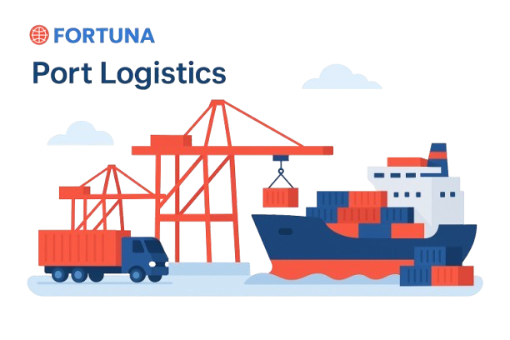

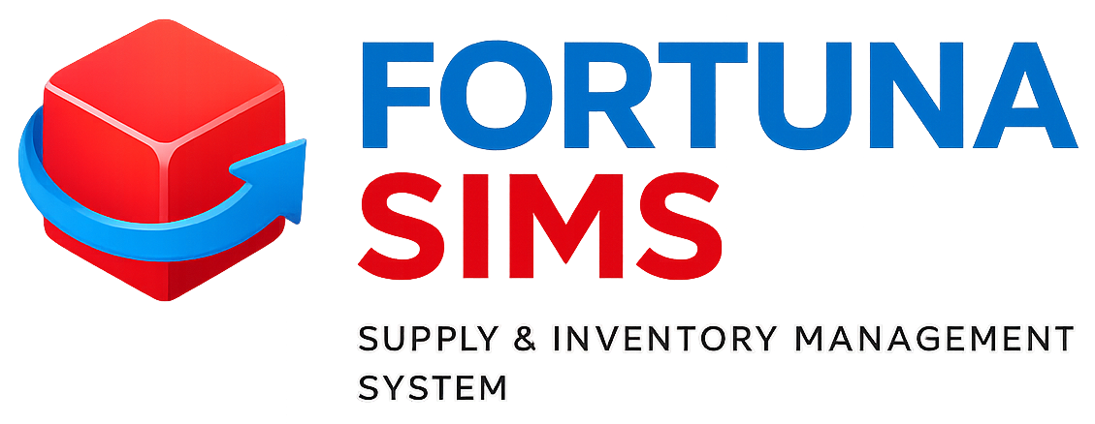

Website: www.fortunaglobalsupplychain.com
E-mail: info@fortunaglobalsupplychain.com

🏢 Company Overview

Fortuna Global Supply Chain Systems is a next-generation enterprise technology company revolutionizing the global logistics and supply chain landscape.
With a vision to create intelligent, transparent, and connected ecosystems, Fortuna blends innovation, data intelligence, and automation to help businesses achieve supply chain excellence.
Established with the belief that efficiency is the new currency, Fortuna empowers organizations to manage operations smarter — from demand planning to last-mile delivery — through real-time insights and seamless digital integration.
We are not just a technology provider; we are partners in transformation — driving global supply chain optimization with precision, performance, and predictive intelligence.

FORTUNA GLOBAL SUPPLY CHAIN SYSTEMS

“The Future of Enterprise Intelligence.”

🌍 1. Fortuna SIMS Overview

“Fortuna -SIMS” is an intelligent, cloud-based platform designed to unify every aspect of the supply chain — from procurement to delivery.
It gives organizations real-time control, transparency, and analytics across purchasing, inventory, warehouse, logistics, and order management — all under one integrated ecosystem.

Core Purpose:
To automate, analyze, and optimize every supply chain function using AI, IoT, and Cloud technologies.
Ideal For: Manufacturers, Distributors, Retailers, and Supply Chain Service Providers.

⚙️ 2. System Architecture
“Fortuna SIMS” operates on a 3-layer architecture:
- Application Layer – Business logic, workflows, dashboards
- Intelligence Layer – AI forecasting, analytics, automation
- Infrastructure Layer – Cloud platform, data storage, IoT device sync
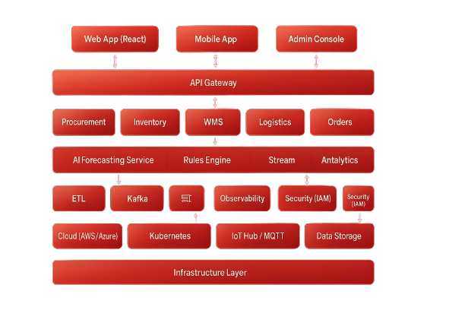

⚙️ 2. System Architecture
“Fortuna SIMS” operates on a 3-layer architecture:
- Application Layer – Business logic, workflows, dashboards
- Intelligence Layer – AI forecasting, analytics, automation
- Infrastructure Layer – Cloud platform, data storage, IoT device sync


🏭 1. Procurement & Vendor Management

📚 3. Product Modules, Sub-Modules & Operational Functionality

📚 Submodules:
- Vendor Master Management – Register and categorize suppliers (local, global, tier-based).
- Purchase Requisition (PR) – Internal request initiation with approval hierarchy.
- Request for Quotation (RFQ) – Automated quotation requests sent to multiple vendors.
- Purchase Order (PO) Management – Convert approved RFQs into purchase orders.
- Goods Receipt Note (GRN) – Record incoming materials, verify with PO.
- Supplier Performance Analysis – AI-based ranking based on delivery time, quality, and cost.

⚙️ Operational Functionality:
- End-to-end procurement automation.
- Multi-level approval workflows.
- Auto-notifications for delayed or pending deliveries.
- Vendor rating dashboards with historical analytics.

📦 2. Inventory & Warehouse Management (WMS)

📚 Submodules:
- Item Master & Categorization – SKU setup, unit management, item attributes.
- Stock Management – Real-time stock updates, FIFO/LIFO handling.
- Warehouse Zone Mapping – Define rack, bin, and zone-based storage layouts.
- Goods Inward/Outward – Automated entry and dispatch tracking using barcode/RFID.
- Stock Transfer Management – Inter-warehouse and inter-location transfers.
- Cycle Count & Physical Audit – Automated reconciliation with IoT devices.

⚙️ Operational Functionality:
- Real-time visibility of stock levels.
- IoT-driven bin scanning for error-free counting.
- Stock reservation and allocation for upcoming orders.
- Smart alerts for understock/overstock scenarios.
- Batch and lot tracking for manufacturing units.

🚛 3. Fleet & Logistics Management

📚 Submodules:
- Fleet Database – Maintain vehicle master, driver details, maintenance records.
- Dispatch Planning – Auto-assign shipments based on location and route priority.
- GPS Tracking Integration – Real-time vehicle monitoring and ETA predictions.
- Delivery Proof Management (ePOD) – Capture delivery proof via mobile.
- Fuel & Maintenance Logs – Automated tracking of operational expenses.

⚙️ Operational Functionality:
- Optimize routes using AI-based mapping algorithms.
- Monitor delivery performance metrics.
- Predict maintenance schedules using IoT data (temperature, engine health).
- Auto-generate trip sheets, load manifests, and invoices.

🌐 4. AI Forecasting & Demand Planning

📚 Submodules:
- Demand Forecast Engine – Predict demand using historical sales and seasonal patterns.
- Stock Replenishment Automation – Trigger purchase orders automatically when safety levels breach.
- Trend Analytics – Identify fast/slow-moving products.
- Sales Correlation Model – Analyze cross-product demand impact.

⚙️ Operational Functionality:
- Real-time forecast adjustments based on live data.
- Multi-warehouse demand balancing.
- Predict shortages before they occur.
- Generate recommended replenishment reports.

📚 Submodules:
- Customer Master Management – Maintain client details, terms, and credit limits.
- Sales Quotation & Order Entry – End-to-end sales flow automation.
- Dispatch & Delivery Scheduling – Auto-allocation based on stock and location.
- Invoicing & Payment Integration – Integrated with accounting systems (E.g. Tally, Zoho, SAP etc).
- Returns & Replacements – Track reverse logistics efficiently.

⚙️ Operational Functionality:
- Real-time order tracking and status updates.
- Manage multi-channel orders (B2B, D2C, retail).
- Set auto-credit checks before order approval.
- Generate invoices, delivery notes, and payment receipts instantly.

💼 5. Sales & Order Management

📊 6. Analytics & Business Intelligence (BI) Suite

📚 Submodules:
- Dashboard Builder – Custom visual dashboards.
- KPI Monitoring – Procurement, logistics, and sales KPIs.
- AI Predictive Insights – Identify upcoming trends and anomalies.
- Reporting Engine – Auto-generate reports by department or location.

⚙️ Operational Functionality:
- Real-time data visualization across modules.
- Export insights to PDF/Excel.
- Predictive analytics for cost and performance optimization.
- Department-wise performance dashboards.

⚙️ Technology & Infrastructure

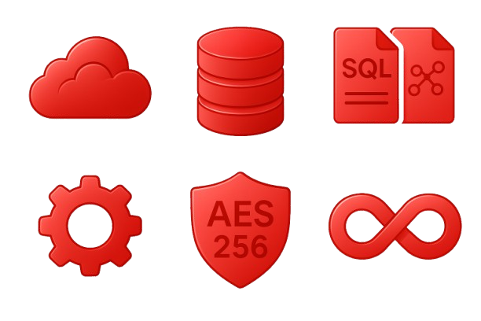

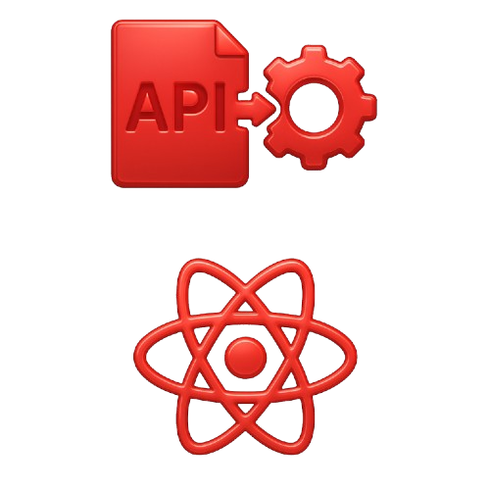
- Security: AES 256-bit encryption, role-based authentication, audit trails.

- Integration: REST APIs, Webhooks, MQTT (for IoT sync).





- Database: PostgreSQL + NoSQL Hybrid.

- Cloud: Multi-tenant, scalable SaaS model (AWS/Azure/GCP).


- Frontend: React JS (Fortuna theme-based UI).

- Backend: Node.js / Python micro services architecture.




Fortuna SIMS Advantages
 | Feature | Benefit
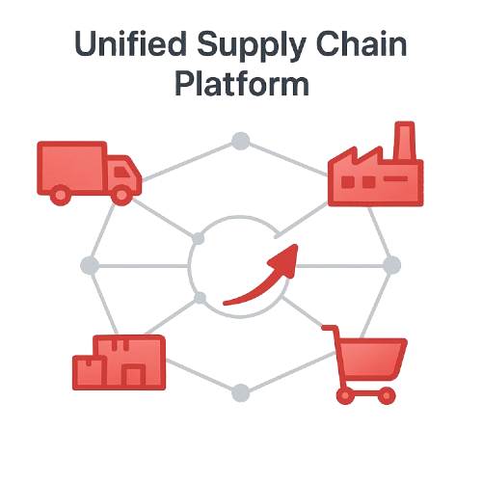 | Unified Supply Chain Platform | Eliminates silos between procurement, inventory, and logistics
 | AI-Driven Forecasting | Reduces stock outs and overstock costs
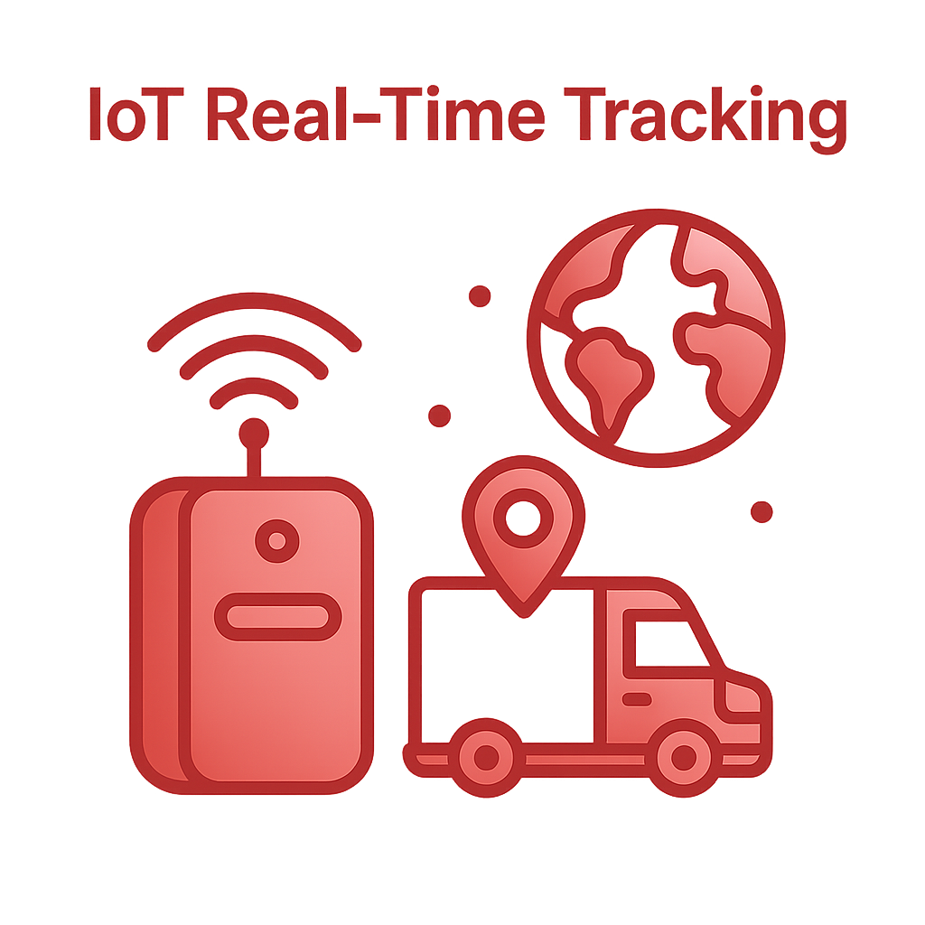 | IoT Real-Time Tracking | Enhances visibility and accuracy
 | Cloud Infrastructure | Scalable, secure, and globally accessible
 | Modular Architecture | Customizable for any industry vertical
 | BI & Analytics Engine | Informed decisions backed by real-time data

🌐 the Fortuna Philosophy

“Fortuna SIMS is not just software — it’s the brain of your supply chain.
Every transaction, movement, and decision becomes intelligent, automated, and connected.”

🚀 Operational Benefits
- 40% improvement in inventory accuracy
- 30% reduction in procurement lead time
- 25% logistics cost optimization through route AI
- 100% traceability across supply chain movements

Automotive & Industrial Manufacturing

🏭 6. Industries Served


FGSCM - supports the automotive sector with advanced logistics planning, vendor coordination, and predictive maintenance scheduling. From global parts movement to plant-level production support, our systems reduce lead times and enhance supply chain agility

Ports & Logistics
•


Fortuna supports the automotive sector with advanced logistics planning, vendor coordination, and predictive maintenance scheduling. From global parts movement to plant-level production support, our systems reduce lead times and enhance supply chain agility

Food & Beverage Distribution
•

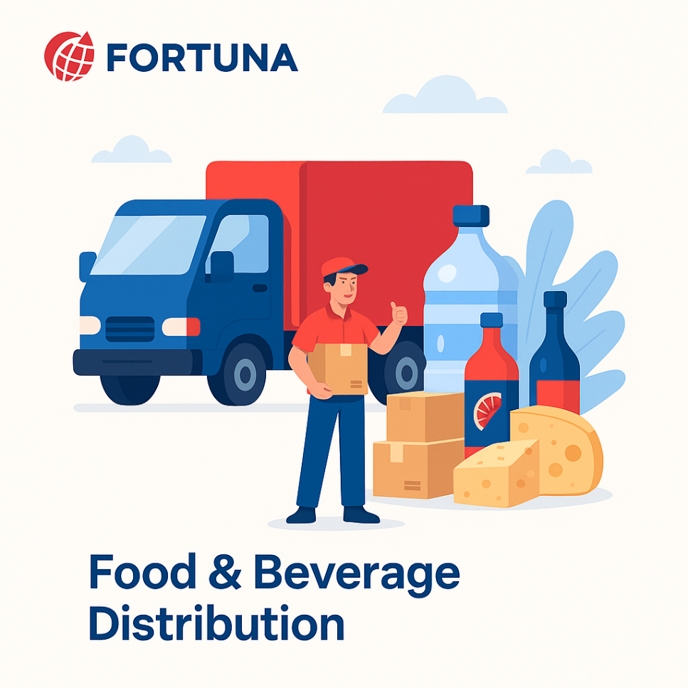
Freshness and safety are at the heart of Food & Beverage -supply chains. We enable end-to-end visibility with IoT-driven tracking, automated quality checks, and predictive demand planning—ensuring traceability from farm to fork.

Fashion & Retail Industry
•


With High seasonal demand & agile supply chain Planning, Fortuna will empowers retailers with faster replenishment & reduces stock outs

Pharma & Healthcare
•


Medical safety and regulatory compliance are non-negotiable. We provide automated solutions for cold chain logistics, product traceability, and compliance monitoring—ensuring life-saving medicines and healthcare products reach destinations safely and efficiently.

E-Commerce & Distributional Channels
•

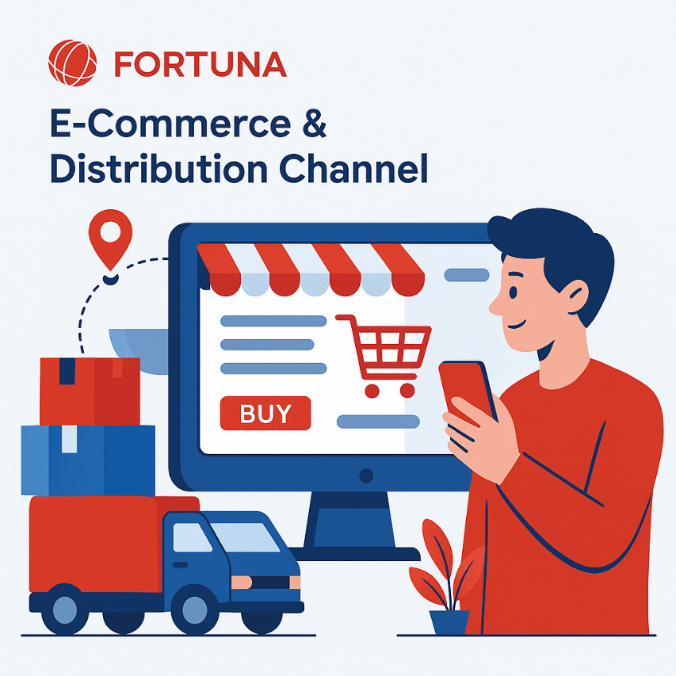
In a fast-moving E-Com world, speed and efficiency are critical. Our platforms enable automated order management, demand forecasting, and last-mile delivery optimization—ensuring customers receive the right products, at the right time, every time.

🏛️ Corporate Identity


Headquarters: Visakhapatnam, Andhra Pradesh, India
Website: www.fortunaglobalsupplychain.com
Email: info@fortunaglobalsupplychain.com

